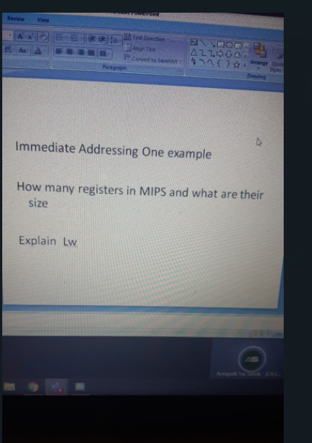

1. immediate addressing one example

An immediate operand has a constant value or an expression. When an instruction with two operands uses immediate addressing, the first operand may be a register or memory location, and the second operand is an immediate constant. The first operand defines the length of the data.

For example,

BYTE_VALUE DB 150 ; A byte value is defined

WORD_VALUE DW 300 ; A word value is defined

ADD BYTE_VALUE, 65 ; An immediate operand 65 is added

MOV AX, 45H ; Immediate constant 45H is transferred to AX

|  |  |
| --- | --- |
| In **immediate addressing**, the actual number specified in the program statement is used as the source operand. For example: | In this example, the hex number 7FH is moved into register CX. However, CX is 16 bits wide, and 7F is an 8-bit number: 0111 1111. Since this number is positive (it has a zero as the msb), the most significant 8 bits of CX are filled with zeros. |

1. how many registers in mips and their size

The MIPS processor has one standard register file containing 32 32-bit registers for use by integer and logic instructions.

1. Lw :

Load word

Similar to LD (load). It copies data from memory and loads into a register

The **LW instruction** loads data from the data memory through a specified address, with a possible offset, to the. destination register. It's syntax is: **LW** $destination register's address, offset($source register's address).